Exam Topics:
(This will be a closed book exam)

Focus on this document, and all materials discussed in class:
  - Quizzes, class notes that I presented, individual assignments.
  - If you have time study the group questions but leave them if you don’t have time.
  - Don’t spend much time with normalization.
  - Transaction management will not be on the exam.
  - ODBC, OLE DB, Reporting, OLAP, XML, and web based data management will not be on the exam.

Topics to know:
- Know how to create an ERD with cardinality
- Referential integrity / Data integrity
- The only things I will ask for normalization are to define the 3 normal forms. I will not go into detail on this.
- DDL, DML, Programming SQL
- Stored procedures and views.
- Understand triggers
- indexes.doc

Presentation questions:
Execution plan
- What is an execution plan?
- What are the benefits of an execution plan?
- Explain the information that might be given when examining the consequences of indexing vs. non-indexing.

Security
- What is the difference between a role and a user?
- Give an example of a GRANT statement that only gives view rights for Bob
- What is a role?
- How do you assign a role to a user?

Encryption
- What is an asymmetric key?
- What is a symmetric key?
- What is a certificate?

Performance and Tracing
- What is SQL Profiler?
- What is Tuning Advisor?
- What is the syntax for the sp_trace_setevent procedure?

Web and xml won’t be on exam.

Question 1:
Puzzle – mind bender.

Week2:
1-How many relationship types do we have?
- One to many (1:M) eg. Student / Classes
- Many to many (M:N or M:M) Note: These are not permitted in relational databases. eg.
- One to one (1:1) eg. Patient / Dental History Chart
2-Explain this diagram in plain English
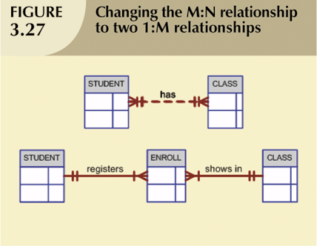

Week3:
- What are the advantages of Storing vs. Not Storing Derived Attributes?
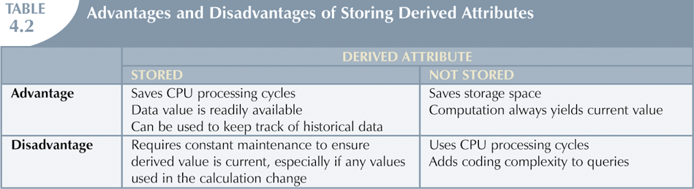

2-Define these terms:
Identifiers (Primary Keys)
- Key attributes are underlined in frequently used table structure shorthand

Composite Primary Keys
- Primary key composed of more than one attribute

Candidate Key
Minimal and a potential for a primary key
Entity Relationship Data Model
- An entity-relationship data model is a detailed, logical representation of the data for an organization or business.

Week4
1-Write the code to create this table in MySql:
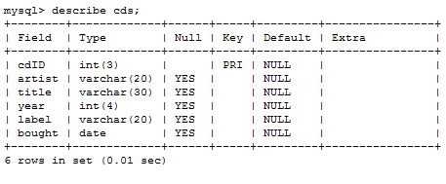
CREATE TABLE cds
( cdID INT(3) primary key,
artist VARCHAR(20),
title VARCHAR(30),
year INT(4),
label VARCHAR(20),
bought DATE );

Week5
1-Insert sample values to this table:
CREATE TABLE tblProduct
(
ProductID INTEGER NOT NULL,
Price MONEY,
CHECK (Price>0)
)

- Question on data redundancy: Show and find redundancy.

- What are 3 ways to translate business rules into attributes and columns

- What is a better way to show this many to many relationship and why change it?

- Explain these keys:
Primary Key
Foreign Key
Candidate Key
Composite Key

- What is a weak entity?
- What is a weak relationship?
- What are the three forms of normalization? Explain them.
- Practical normalization example.
- Be able to look at a row (tuple) and determine which normal form is being used.
- We may choose to use a star schema when storing data in a warehouse. Why store data in a data warehouse? What is a data warehouse? What kind of data might we choose to omit from a data warehouse?
- Here are some business rules. What are the relationships? Which are mandatory vs. optional.
14.To avoid redundancy how would you change these attributes?

